J a n n a

A H r n d t

## Halloween 1990 & Waterloo House 1992

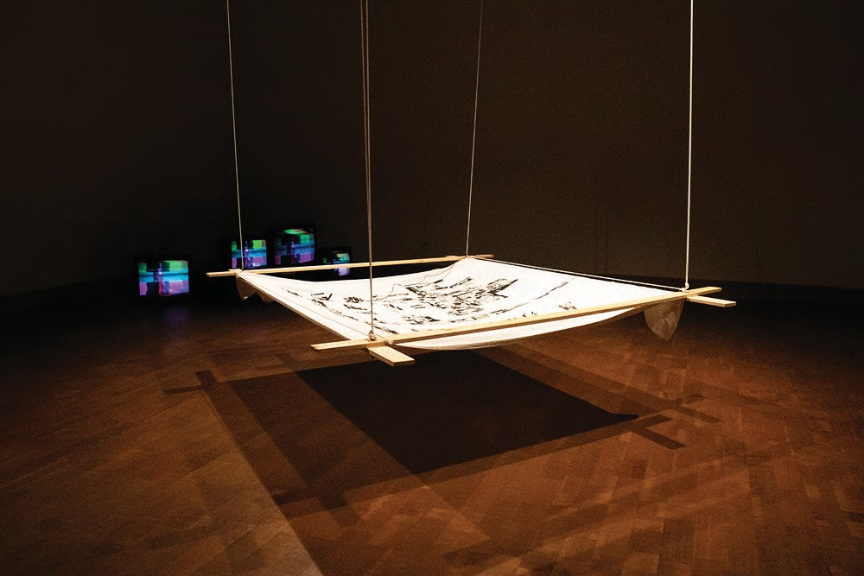

Halloween 1990 & Waterloo House 1992 (Conductive Ink on Cotton, Copper Wire, Alligator Clips,

Deconstruction and resetting has long been a strategy of Glitch, circuit bending, and political art practice. Dissecting, rearranging, and reworking shared signs and symbols- wires and electrons- is a gratifying way to dismantle systems that have been built to exclude and exploit. By first digitizing and then running these videos through a image recognition machine learning algorithm I have altered and changed them forever -making them more malleable causing me to question the nature of memory and remembering in a time before smartphones. In this work the technology is serving both as a prosthetic for my own flawed memory as well as a means of distancing myself f rom the emotional task of self- archiving. Halloween1991& Waterloo House 1992 is a circuit bending and video mixing experiment where the quilt becomes a potentiometer allowing participants to glitch and warp my home videos.

[Halloween 1990 video](https://youtu.be/eH2ZYxhw82k) [Waterloo House 1992 Video](https://youtu.be/i57G5j0HQLg)

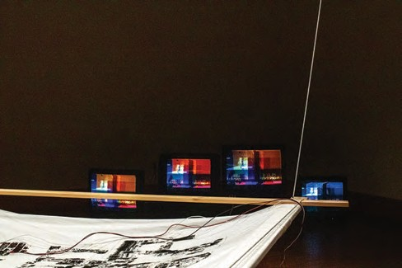 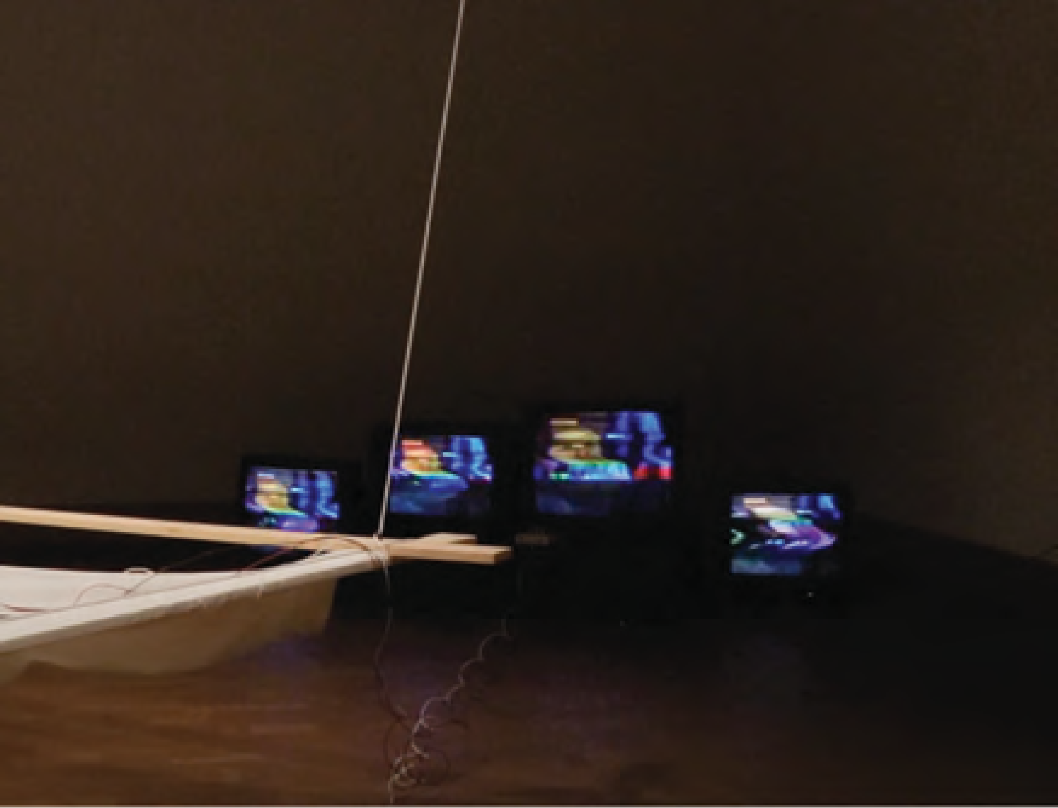 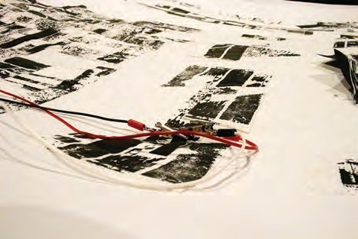

## Halloween 1990 & Waterloo House 1992

[Link To Video](https://youtu.be/BRQkJpJpVnA)



**DIRTY VIDEO MIXING QUILT**

**TV**

**TV**

**TV**

**TV**

**TV**

**TV**

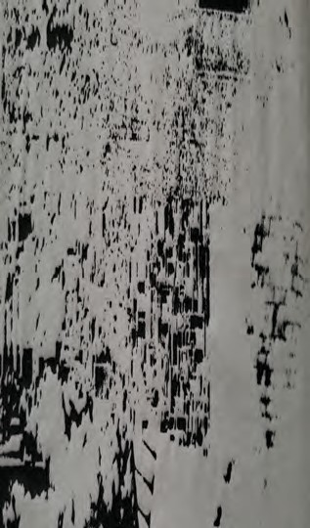**VID 1**

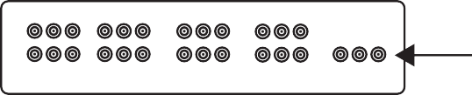

**TV**

**TV**

**VID 3**

**VID 5 VID 7**

**VIDEO IN FROM MIXER**

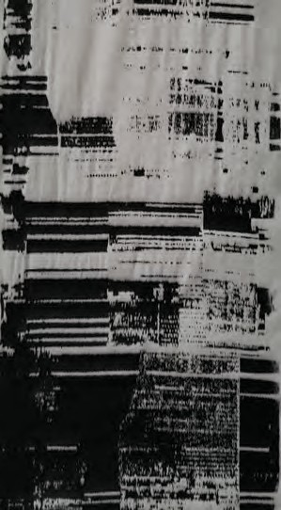**VID 2**

**VID 4 VID 6**

**VID 8**

**VIDEO OUT TO RCA SPLITTER**

**VIDEO IN VIDEO IN**



**SWITCHES FOR LEFT AND RIGHT CHANELS**

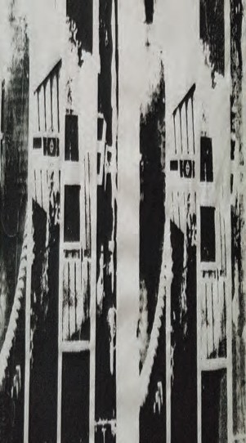Images of my Parent’ s Home Screen Printed in Conductive ink

**VIDEO SIGNAL 1**

**POTENTIOMETOR**

**MIXING THE TWO SIGNALS**

**VIDEO SIGNAL 2**

**CONDUCTIVE PORTIONS OF THE QUILT**

* **THE SIGNAL CAN ONLY TRAVEL THROUGH THE**
* **CONDUCTIVE INK OR CONDUCTIVE FABRIC.**
* **ALL THREE PARTS OF THE CIRCUIT NEED TO HAVE**
* **CONTACT WITH THE SAME CONDUCTIVE MATERIAL TO MIX**

## Speaking Hypothetically

#### Using a dataset of different redacted texts relating to the Mueller Report/current events and training a very simple Markov Chain text generator, Hypothetically Speaking seeks to expose some truth by pure chance. Theoretically by constantly generating paragraphs of text, one could assume that **eventually** some of the redacted portions of the text would be generated by the algorithm. The program then decides which sentences it deems to be important and prints them on thermal printer paper to be followed up later. Could we expose some state secrets on accident? Maybe?!

[Link To Website](https://speakinghypothetically.com/)

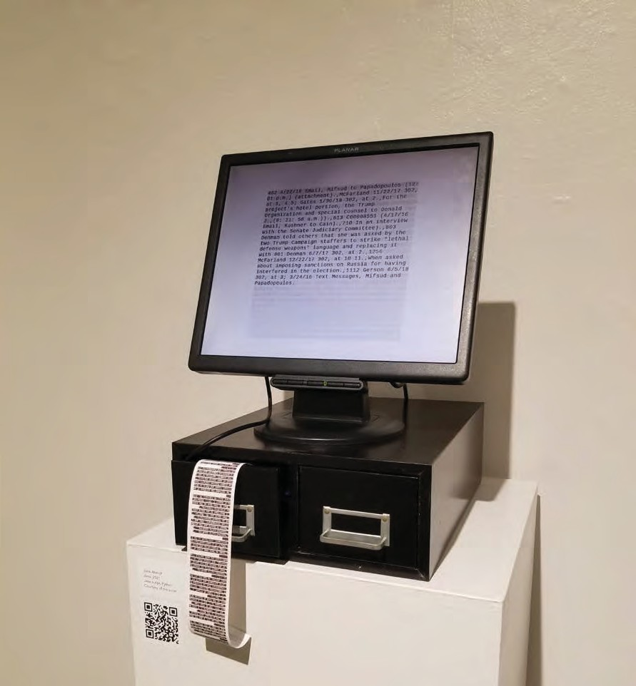

Speaking Hypothetically (Monitor, Thermal Printer, Filing Cabinet, Raspberry Pi), 2019-2020

�

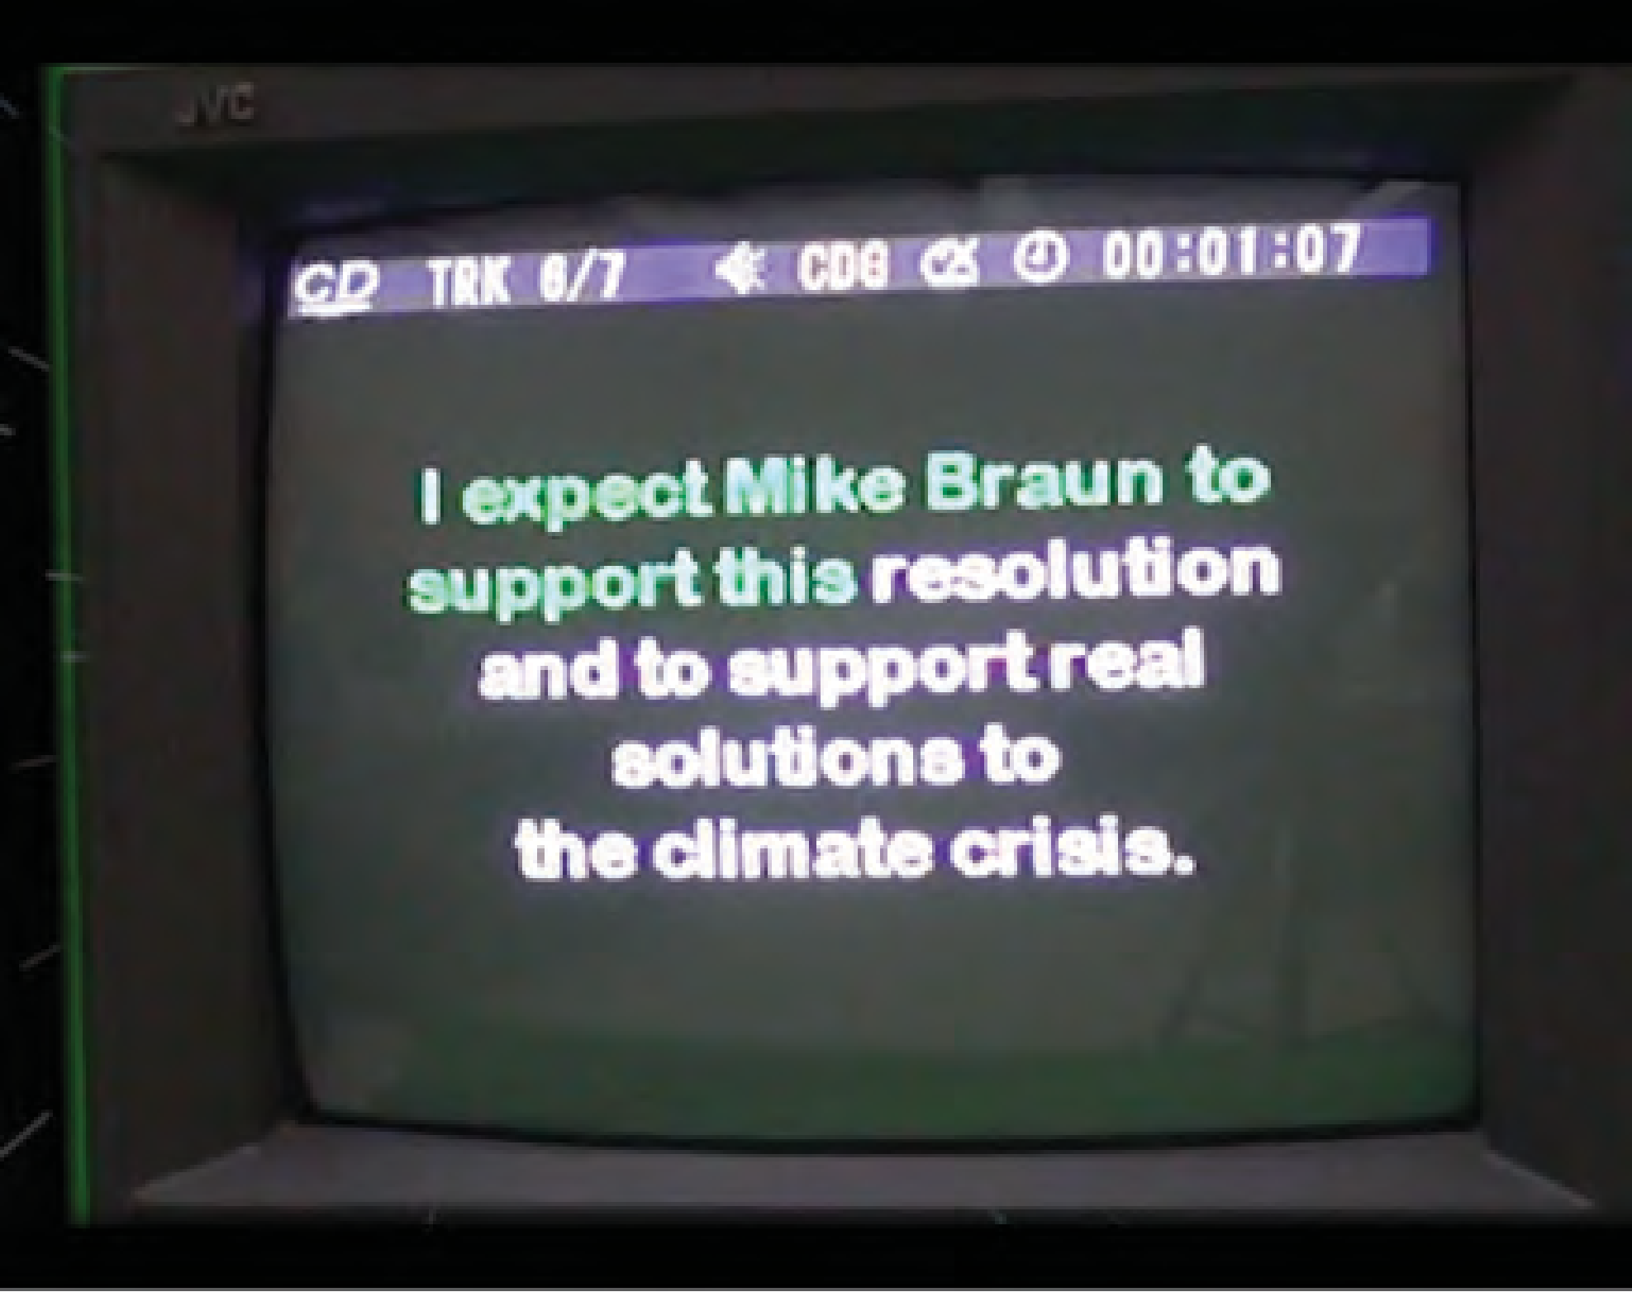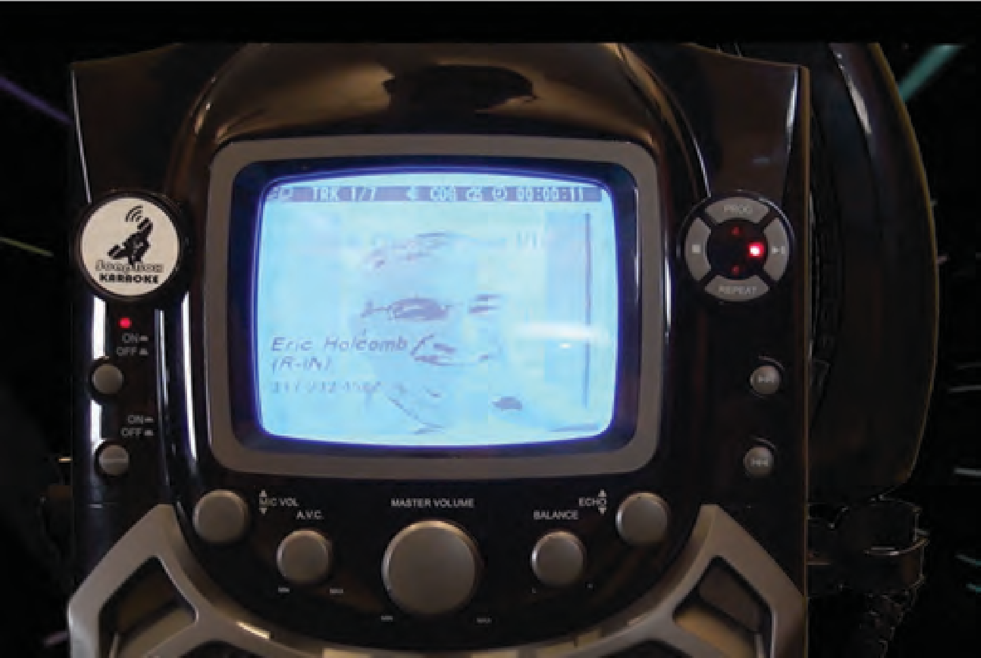[Link To Video](https://youtu.be/quwso0IReWg)

## SoapBox Karaoke

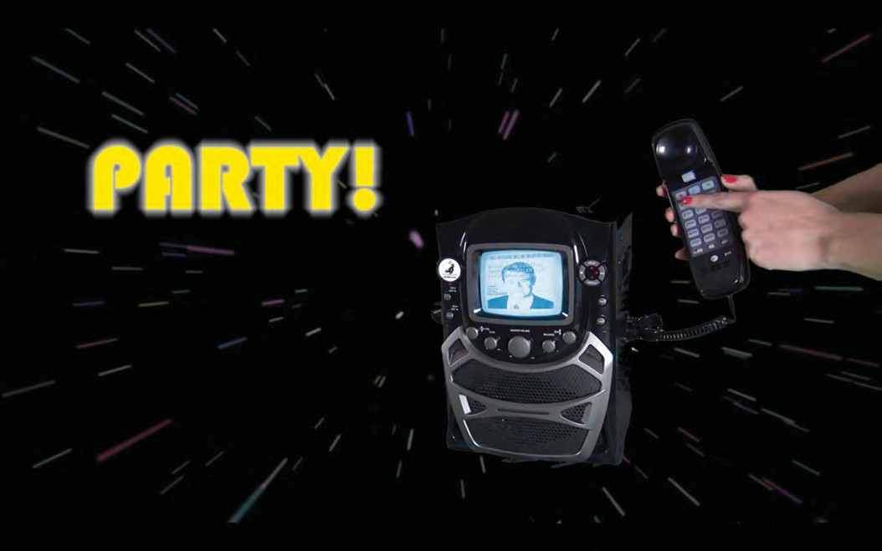SoapBox Karaoke is an interactive installation. The self-contained socially powered Karaoke machine is equipped with a landline telephone and private number. To use the machine, simply press play. Then, choose a track from a CD, and dial up their senator or representative and sing along into the phone. Each track is backed by Muzak from various archives reminiscent of being on hold. You may also choose to practice your script first by singing it into the microphone.

SoapBox Karaoke (Vintage Singing Machine Classic, CD+G software, CDs)

2019-2022 �

## Deepest Condolences

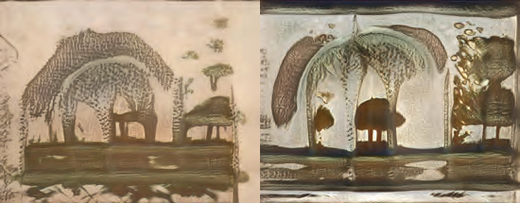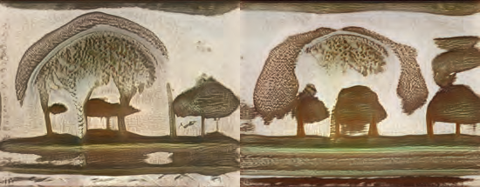

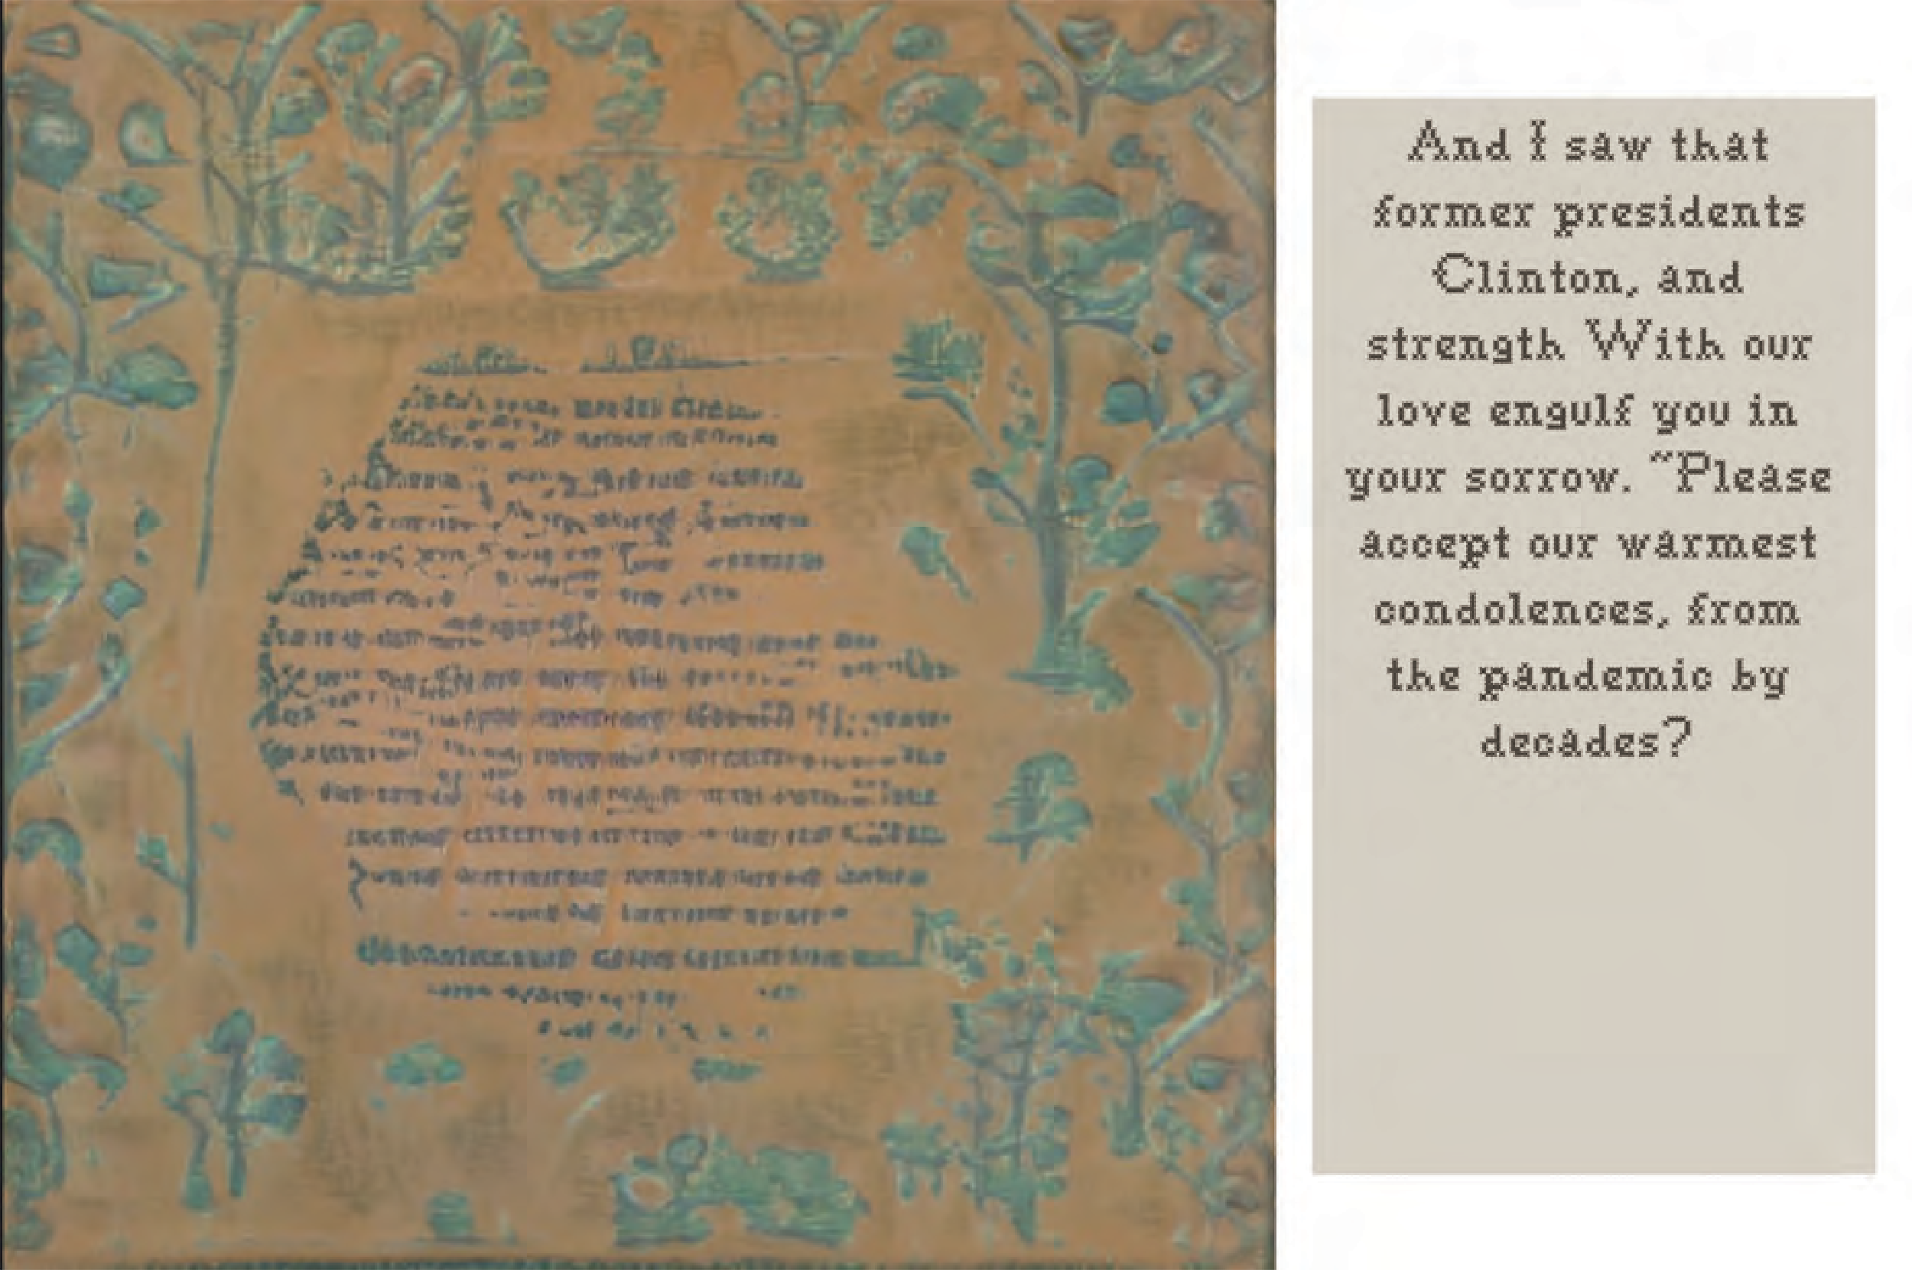

Deepest Condolences (JavaScript, GAN, Dataset : Transcripts of Hallmark Cards and Political Speeches) 2022

There is a long-standing expectation for feminine sentimentality in Western culture. Women have been the family historians and curators, saving objects and images to later be passed down as the family archive. This expectation extends into cultural practices surrounding mourning and death. Often in times of mourning women are the primary archivists and creators of memorial and sentimental objects for the family after the death of a loved one. In this paper I try to reconcile the traditional role of mourning ritual - language and iconography with generative computing art making in the time of Covid-��.

The text on each card in generated using a predictive algorithm that uses a dataset of Hallmark Cards and Political Speeches about Covid-�� relief packages. The images are derived using a machine learning process called a GAN (Generative Adversarial Network) trained on a dataset of mourning sewing samplers from the ����’ s and ����’ s.

Generating condolences is an expression of communal grief during a global crisis. It is my intention to reexamine traditions surrounding a womxn’ s role in the grief and mourning processes while using this work as a public intervention that also questions the often hallow words of condolence we receive from political ﬁgures during a time of crisis. As I develop this work into a public installation it is my hope for participants to generate and mail condolence cards to government representatives who are endangering communities by refusing to pass common sense mask and vaccine requirements or just to tell their own pandemic story.

[deepestcondolence.com](https://deepestcondolence.com/) �

## MAKE FLOORS GREAT AGAIN

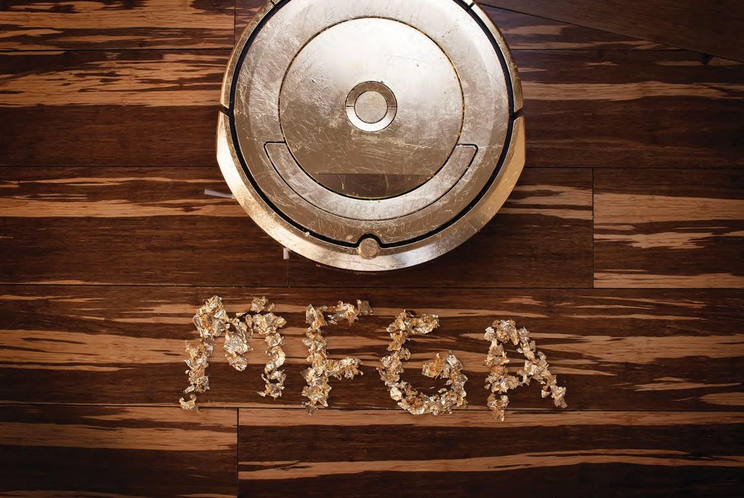

MFGA (Make Floors Great Again) (IFTTT, iRobot Roomba, Gold Leaf), ����-����

#### Using an applet created with the IFTTT platform, The Roomba reacts to Donald Trump’ s twitter feed. Each time Trump tweets, the Roomba begins a cleaning cycle. The more he tweets the cleaner the floors become.

Since Trump’ s account was banned from Twitter the applet reacts to people using the hashtag #DonaldTrump.

**INTERNET OF THINGS AS PERFORMANCE:**

**Technology is so undeniably embedded in our daily lives in the form of house appli- ances, media platforms, electronic gadgets, we can become almost blind to it. By hijacking everyday technologies or even making our own, we can jolt ourselves into questioning the ways in which they are created, marketed, and used. Using these pervasive technological systems in ways they were not intended produces an oppor- tunity for guerrilla art tactics. In At the Edge of Art, Joline Blais and Jon Ippolito compare digital art to antibodies, stating “digital art perverts codes, arrests normal operations, recalls latent information or meaning, executes instructions, triggers mechanisms to recognize its activity and preservers in memory [1].”**

**ABSTRACT:**

**MAKE FLOORS GREAT AGAIN**

**MFGA (Make Floors Great Again) is a robotic performance piece Currently taking place on** [**http://makefloorsgreatagain.online/.**](http://makefloorsgreatagain.online/) **Using an applet created with the IFTTT plat-form, The Resistance Roomba reacts to Donald Trump’s twitter feed. Each time Trump tweets, the Roomba begins a cleaning cycle and sends him a thank you tweet. The more the US President tweets the cleaner the floors be-come. With the passing of the impeachment inquiry in the House of Representatives and the upcom- ing election, I expect the floors will be cleaner than ever. The Roomba, lovingly named Rupert Murdock, is gilded in faux gold leaf giving it a kitsch aesthetic worthy of Trump Tower.**

**Platforms such as IFTTT, designed to increase usefulness of IOT technologies, can**

**REFERENCES:**

Books

1. Blais, Joline, and Jon Ippolito. At the Edge of Art. London: Thames & Hudson, 2006.
2. Raley, Rita. Tactical Media. Minneapolis: University of Minnesota Press, 2009.

**Using an applet created with the IFTTT platform, The Resistance Roomba reacts to Donald Trump’s twitter feed. Each time Trump tweets, the Roomba begins a cleaning cycle.**

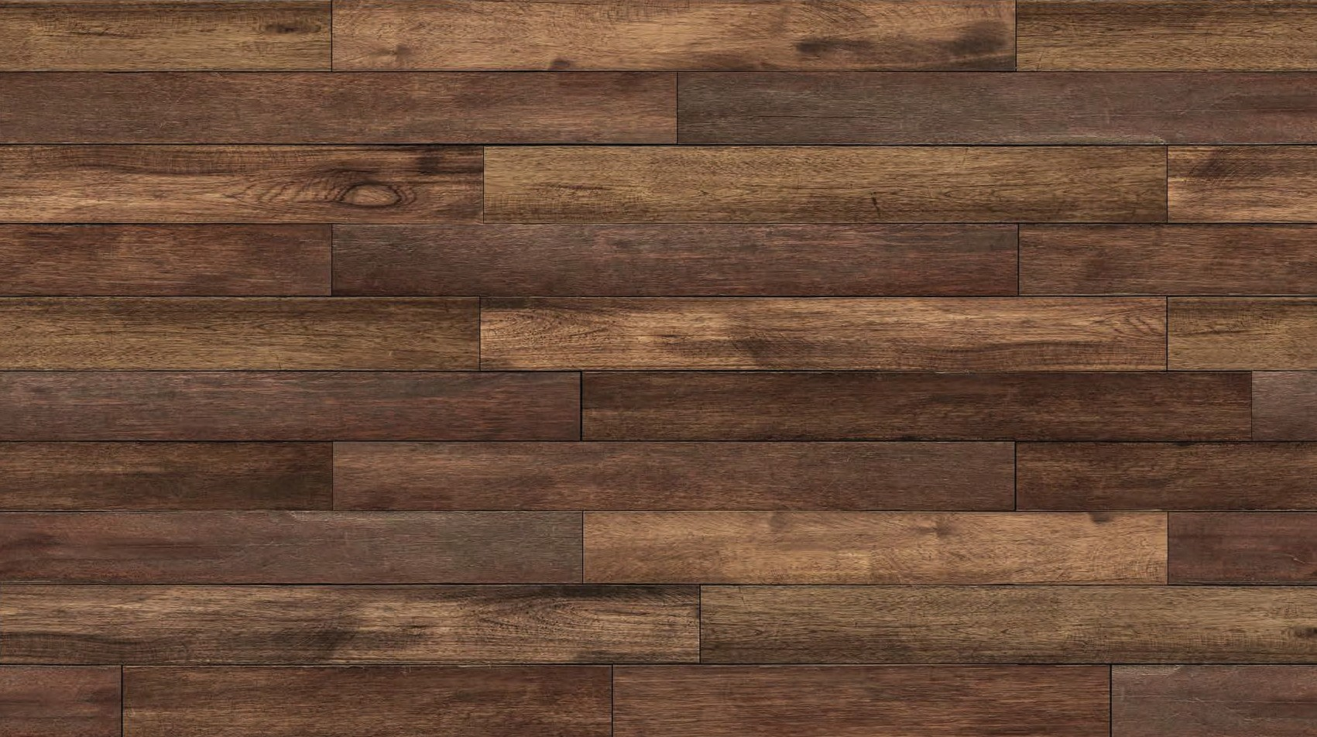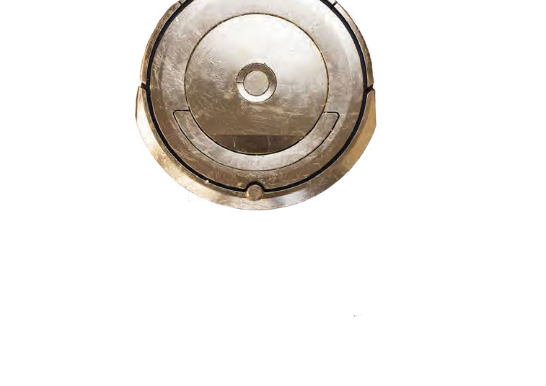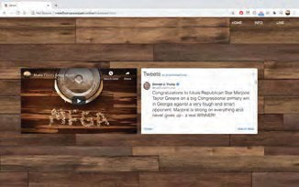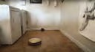

**INTRODUCTION:**

**MFGA (Make Floors Great Again) is a robotic performance piece. Using an applet created with the IFTTT platform, The Resistance Roomba reacts to Donald Trump’s twitter feed. Each time Trump tweets, the Roomba begins a cleaning cycle. I believe this subversion can be used to provoke action as a part of a participatory/critical art practice. Tech- nology is so undeniably embedded in our daily lives in the form of house appliances, media platforms, electronic gadgets, we can become almost blind to it. By hijacking everyday technologies or even making our own, we can jolt ourselves into questioning the ways in which they are created, marketed, and used. Using these pervasive technological systems in ways they were not intended produces an**

**opportunity for guerrilla art tactics.**

**be a way for tactical media artists to create tools in the form of applets that push the critical potential of this interconnectedness outside and beyond the systems and corporations that created them.**

**CONCLUSION:**

**This project seeks to subvert the power of the rich via the connectivity of the Internet and exploring how we as artists can combine these interconnected technologies to create a new medium for art. I cannot help but be satisfied knowing a man that has never cleaned a floor in his life unknowingly cleans mine multiple times in a day.**

**We are coming to terms with the consequences of largely unregulated optimism about all of this interconnectivity. Rita Raley stated in her book Tactical Media, “Tactical media is perfor- mance for which a consumable product is not the primary endgame; it foregrounds the experiential over the physical [2].” As we enter the second decade of the twenty-first centu- ry, we sit upon a huge stockpile of con-sumer convenience technologies all connected to the inter-net of things. There has been a rich history of instruction art as a form of critical media that I am interested in exploring through tactical connectivity. By strategically exploiting the ability for anyone to make connections be-tween these technologies, we can combine them to have a more democratic discussion not only about these consumer technologies, but also the systems that drive them.**

**BIOGRAPHY:**

**Janna Ahrndt received her MFA in Electronic and Time Based Art from Purdue University and is currently the Visiting Assistant Professor of Digital art at Indiana University. She is a part of a wave of new media artists rejecting the notion that craft and technology are direct- ly opposed. Her work explores how deconstructing everyday technologies can be used to question larger oppressive systems and create a space for participato- ry political action. Her activist and social art practice seeks to blur the lines between the materiality of craft and the digital realm of new media technologies to create socio-political interventions. She has presented research on the use of DIY electronics as a medium for participatory political art at ISEA 2019 in Gwangju South Korea and facilitated work-shops in collaboration with the Science Gallery in Melbourne Australia, the Science Gallery in Dublin Ireland and the NEoN Re@ct festival.**

**CONTACT:** [**jahr**](mailto:jahrndt@iu.edu)[**ndt@iu.edu**](mailto:ndt@iu.edu)

# P@tch

Like a Fitbit for your ethical performance, P@tch is a hand-embroidered patch that allows the user to track their progress as an advocate for an ethical stance. This project utilizes the ethos of Punk, DIY/Lo-fi, and digital opensource movements by posting all sources material, and instructions online for anyone to access. By posting all of these resources on my website I hope to foster a

new media art and tech fields in general.

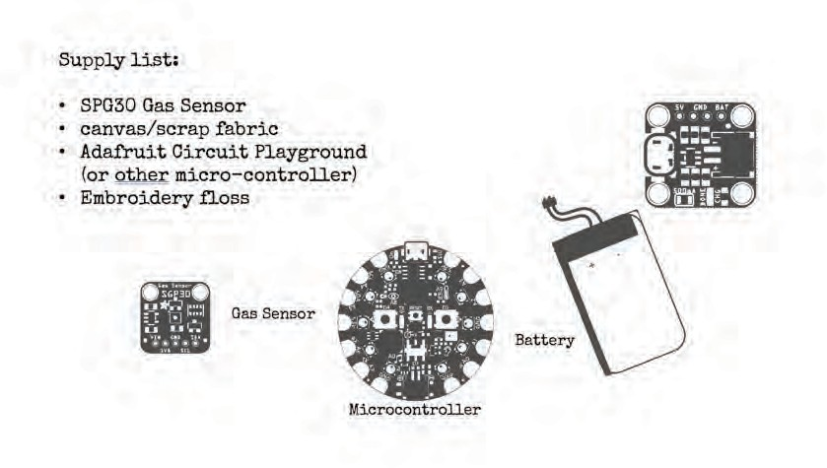The main components of P@tch are an RGB color mixing LED light, a small sewable microcontroller, a Bluetooth module, and a button switch. This wearable is made with

circuits directly into the fabric of their patch.

The Bluetooth module connects to the Adafruit Bluefruit app on their phone which then sends self-reported data to a feed on an open source platform. It then triggers another online application created using IFTTT to transmit data from their feed to their twitter account.

[Video Playlist of instructional videos](https://youtube.com/playlist?list=PL0qdYFhePtBD4mgMNyxRJZBHsbXreCsKN)

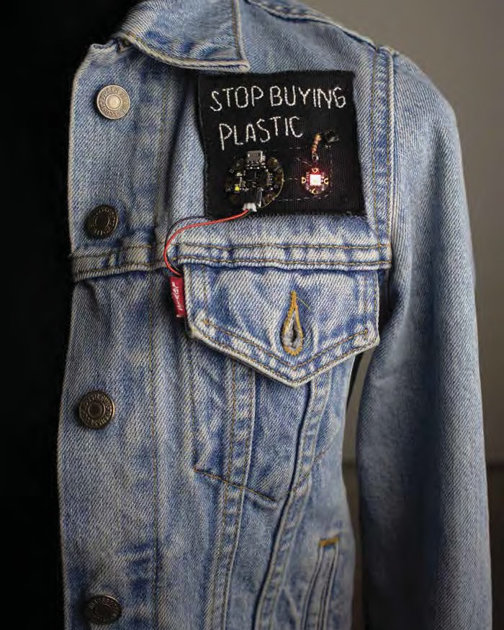

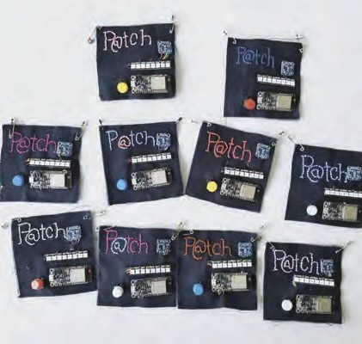

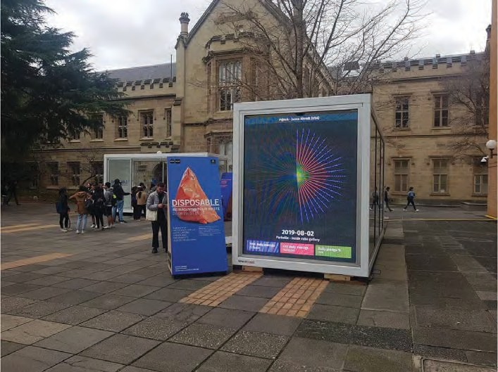

University Of Melbourne Digital CO2 Display for P@tch

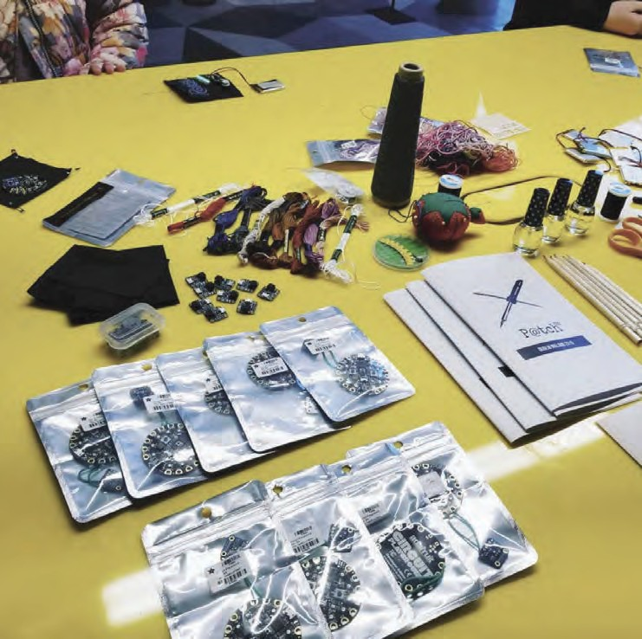 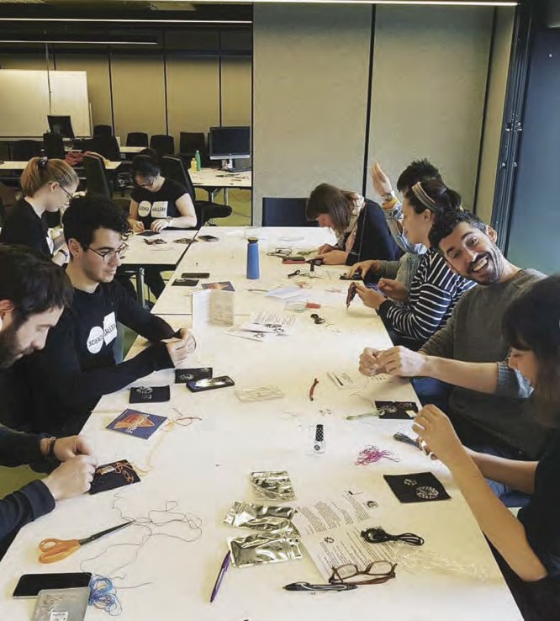

P@tch Materials Science Gallery Dublin Ireland Science Gallery Melbourne Australia

**PeepingTom 2.0**

### Site Specific Installation at a historically all male Engineering Camp in the Women’s Bathroom. When walking into the space it is illuminated only by red light. You navigate the dark underground bathroom using provided flashlights and your mobile device. This work explores



as harmless fun – the viewer is placed as both voyeur and subject as they walk through the space. The embroidered undergarments act as image targets that activate an Augmented Reality Application playing looped and edited video. It was my goal of this piece to explore the feelings of puberty and navigating public and private spaces in a culture where this was viewed as both comedic and taboo behavior.

[Installation Videos](https://youtube.com/playlist?list=PL0qdYFhePtBAd53tcPoxLVnOWJjvfQokx)

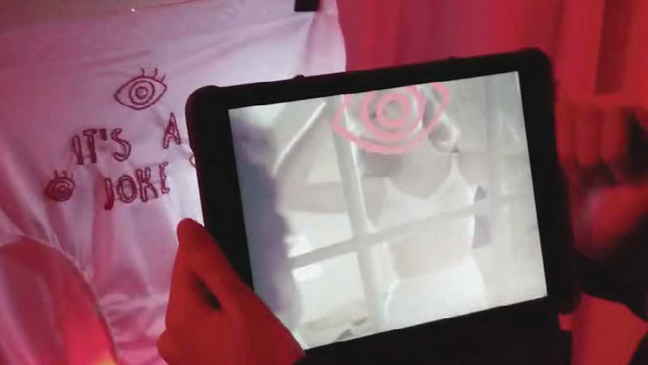

Janna Ahrndt, Peeping Tom 2.0,

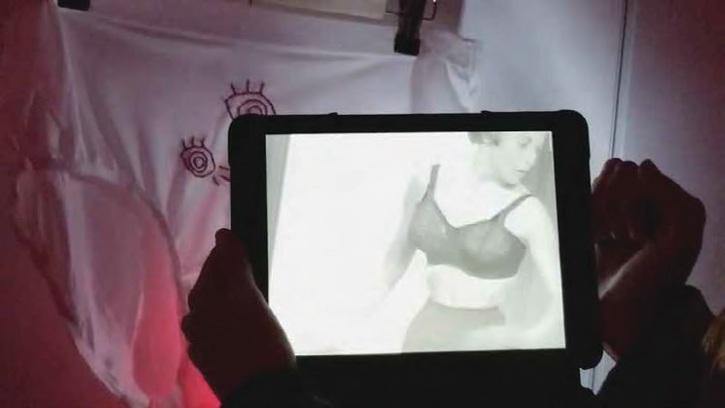Site Specific Augmented Reality Installation, App created for iPad, 2017

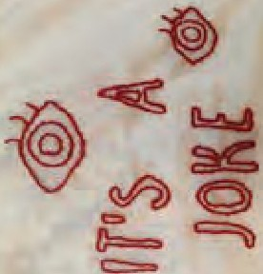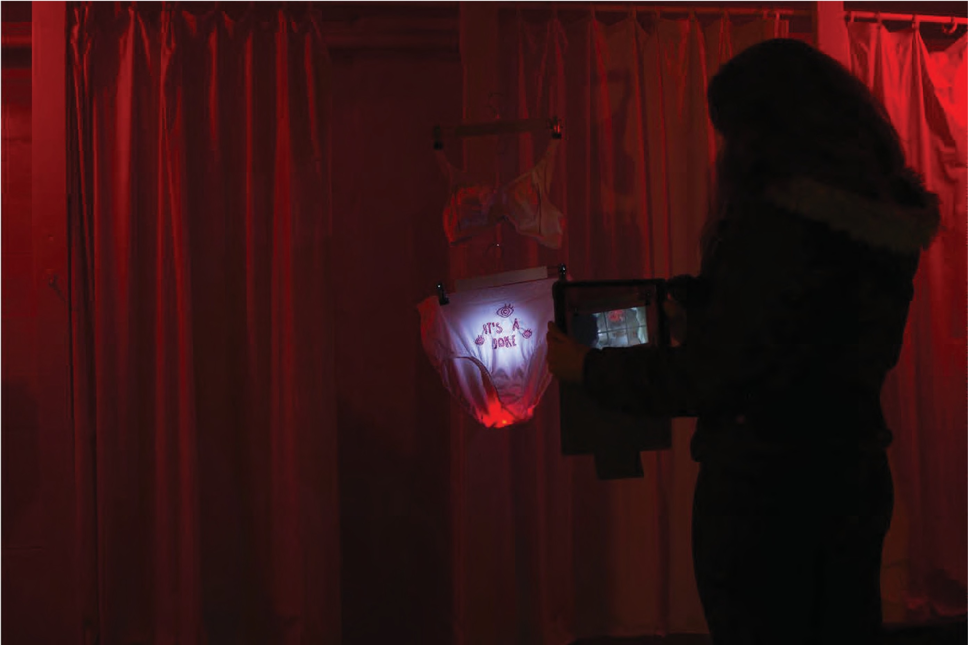

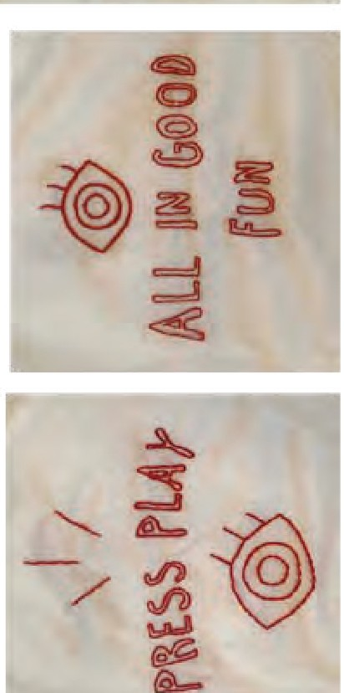

�{@

i@)�

*:1@)*



�

# Timely Warning

The Jeanne Clery Disclosure of Campus Security Policy and Campus Crime Statistics Act requires all universities and colleges that receive federal financial aid to keep campus crime statistics and security information and make them available to the public. While I believe this statute to have a positive impact on the transparency and prevalence of instances of rape and sexual assault, the way Purdue University shares this information is not helpful and obscures the intent. Is it to draw attention to the crimes? Is it to tell students to



not typically go to the police immediately.

The most egregious aspect of these emails is the prevention tips that

to victims of these crimes, and many of them make absolutely no sense. A tip such as, “define your sexual limits and practice being assertive about your boundaries,” as if the perpetrator of these kinds of crimes cares about your boundaries as if there was merely some misunderstanding between the predator and the victim. This is gross. Since when are rapists willing to listen to your limits? That is exactly what makes them rapists. These emails do nothing to help stop the toxic culture that created this problem in the first place and rely on the same old tired argument that if only victims were more vigilant, they would not have been targeted.

[Video Documentation of Walking Performance at assault locations alone at night.](https://youtube.com/playlist?list=PL0qdYFhePtBCoQZZ5XehR_6VgtcYyDSE9)

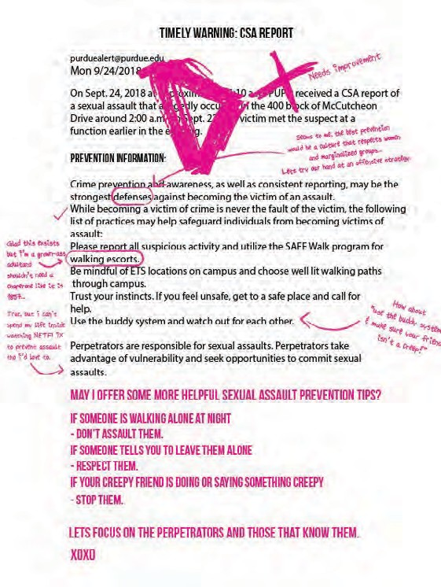

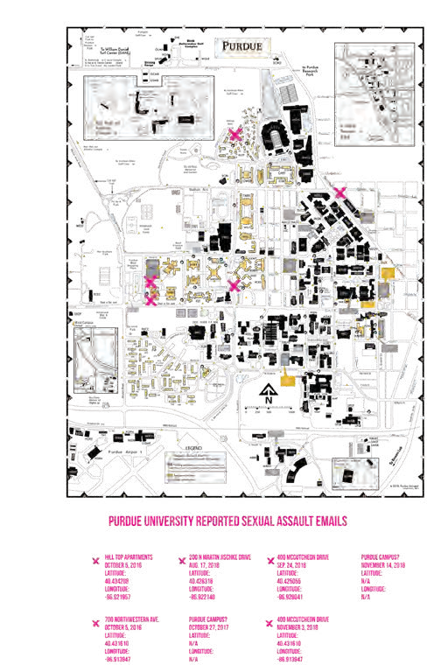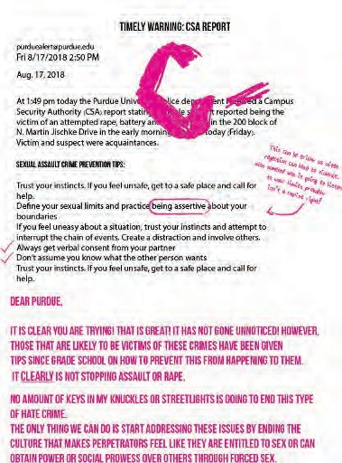Janna Ahrndt, Timely Warning Sep. 24, 2018

11 x 8.5, Digital Graphic Guerrilla Poster , 2016 - Until the Asaults Stop

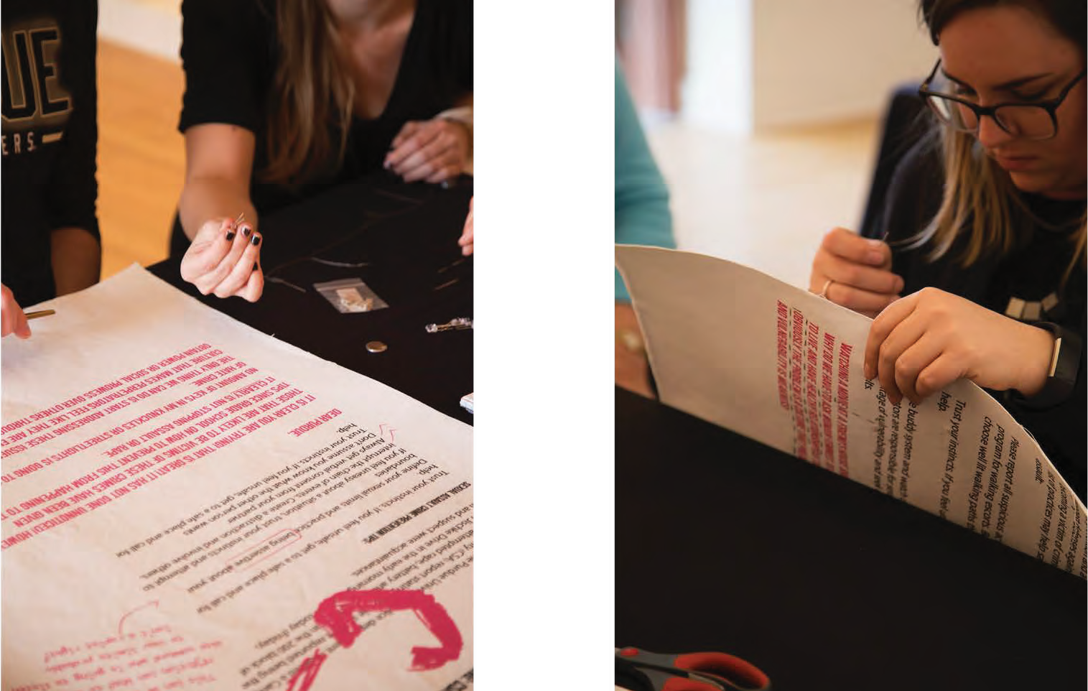

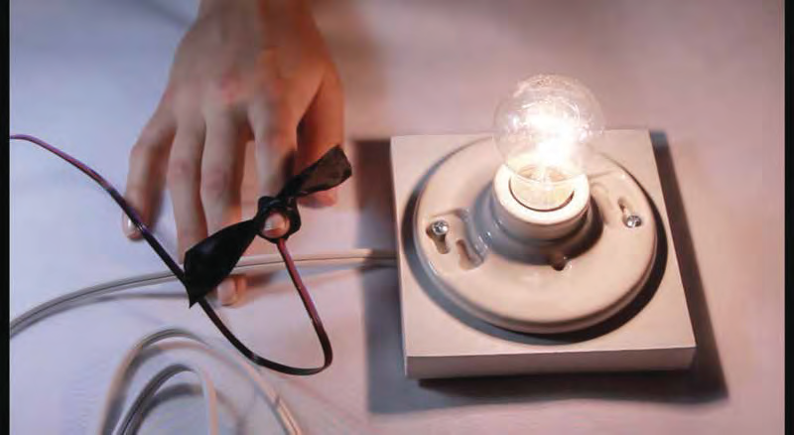 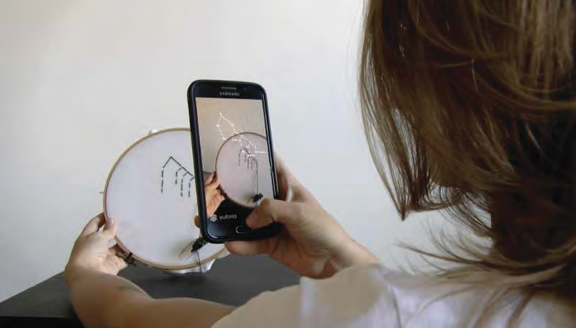

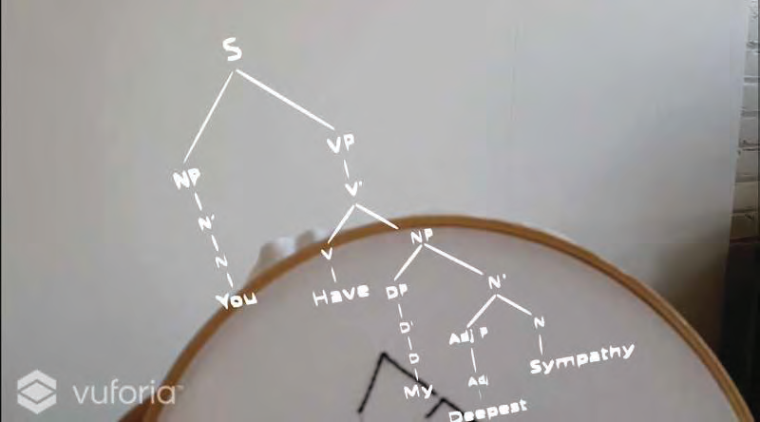

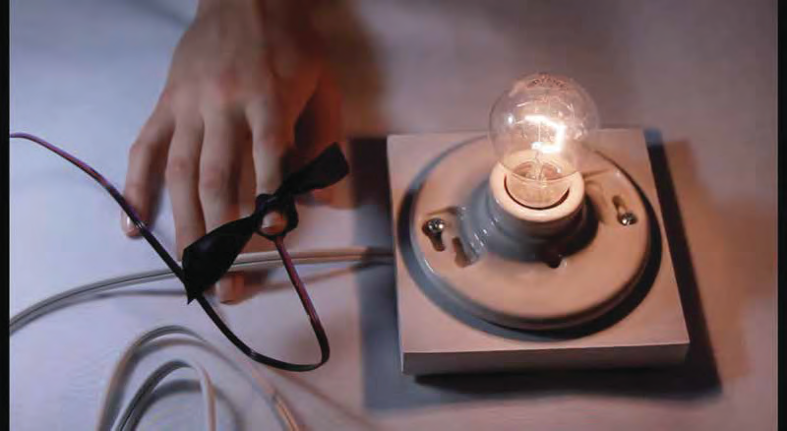Janna Ahrndt, Dark,

Pulse Sensing Mortality Lamp , 2016

Janna Ahrndt, Syntax of Grief,

Augmented Reality Application and Embroidry Hoop , 2017

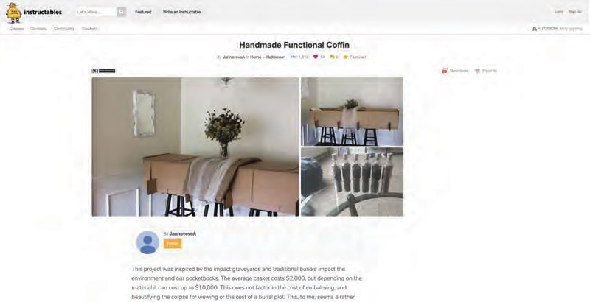

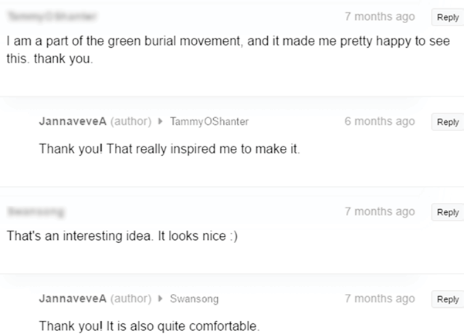

Janna Ahrndt, Green Burial Handmade Functional Coffin Instructable

62 x 18.5, Cardboard Coffin Made from Home Depot Boxes Under $30, 2016

Janna Ahrndt, Handmade Functional Coffin Blue Prints

62 x 18.5, Cardboard Coffin Made from Home Depot Boxes , 2016

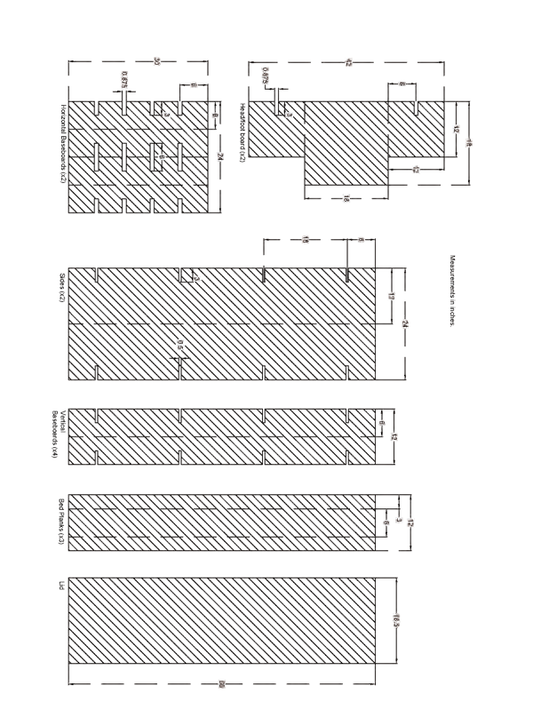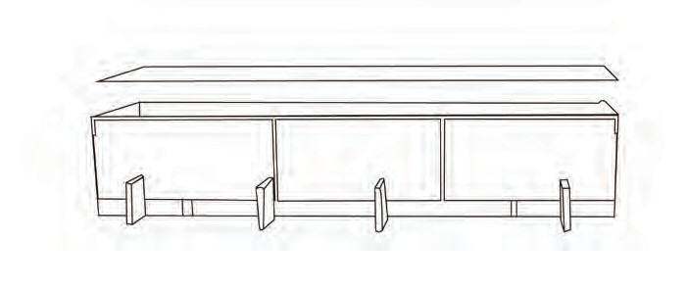

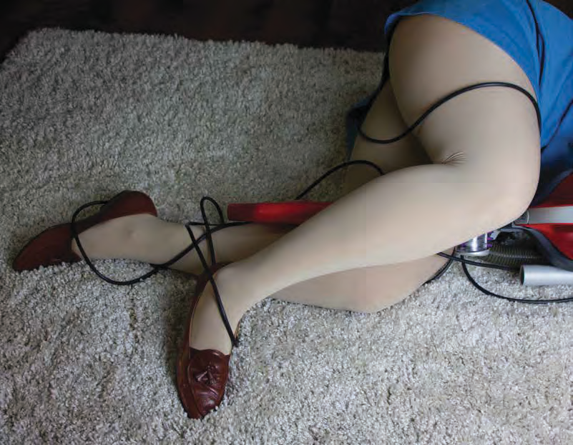

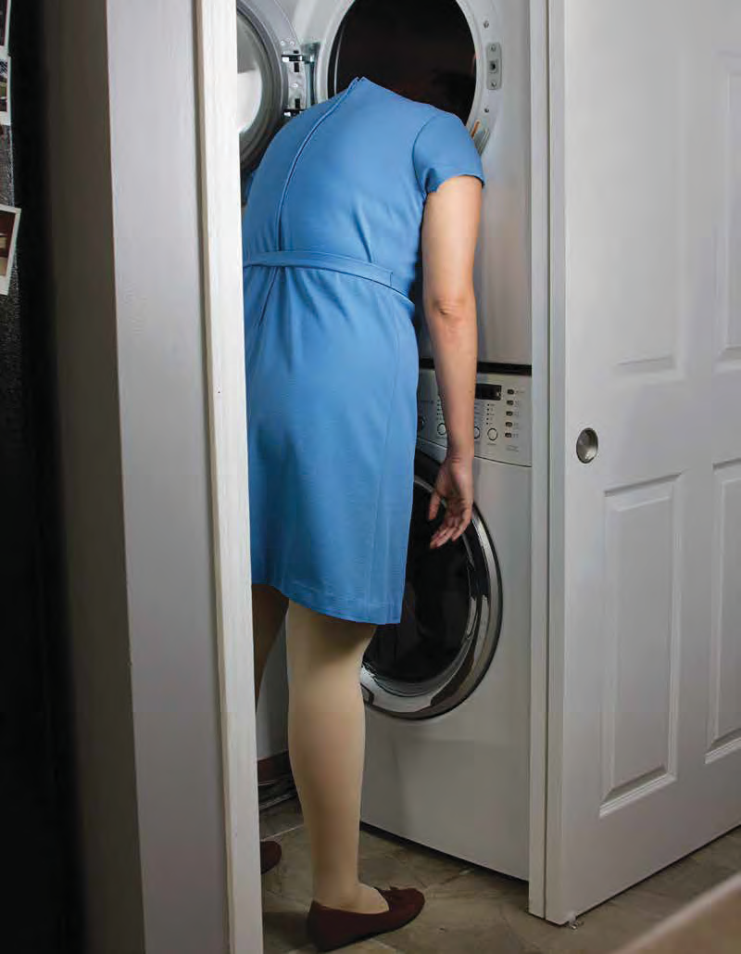

Janna Ahrndt, #DomesticQueen 01 17x11, Digital Photo Print , 2018

Janna Ahrndt, #DomesticQueen 04 11x17, Digital Photo Print , 2018

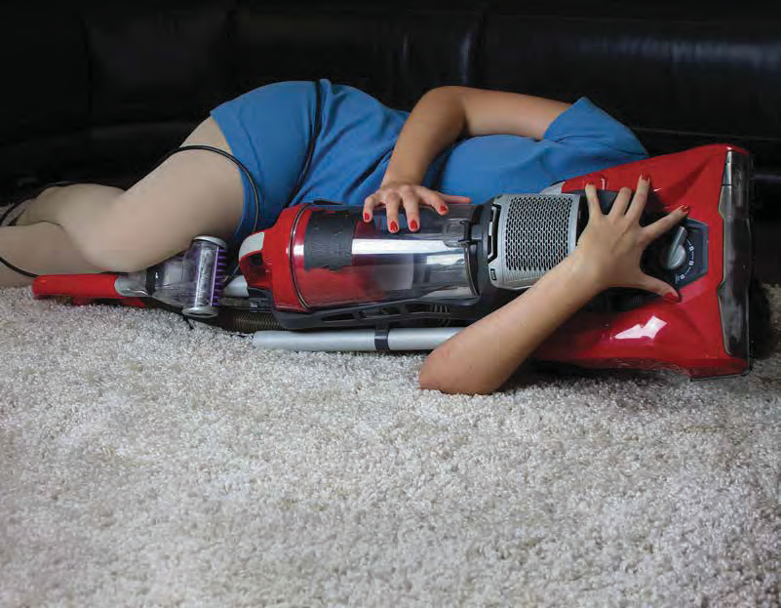

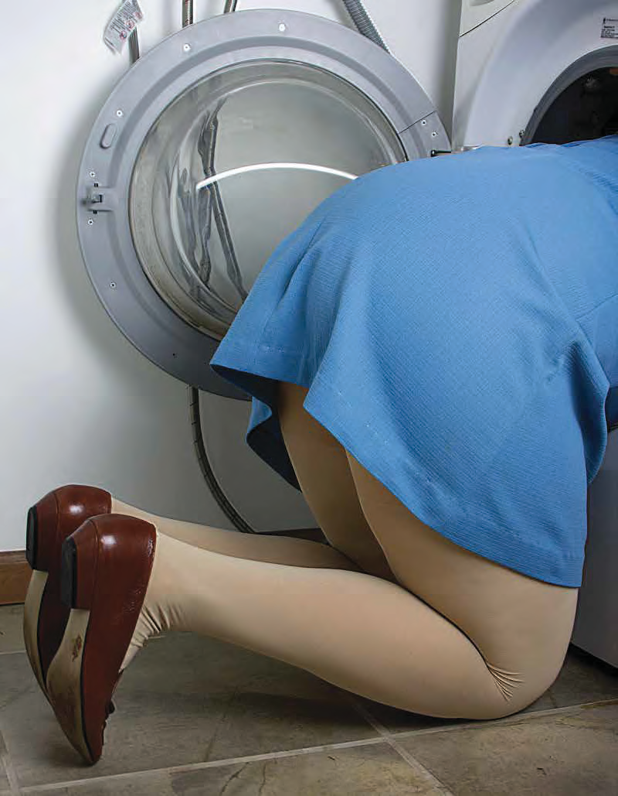Janna Ahrndt, #DomesticQueen 03 11x17, Digital Photo Print , 2018

Janna Ahrndt, #DomesticQueen 02 17x11, Digital Photo Print , 2018